**How to use button and changing levels**

Firslty, create multiple levels of the game .You can create new level by pressing ‘ctrl+N’ or by going to File -> Select New Scene.

Your scenes name should be like this – Level1,Level2,Level3 ……

In each level where ball will come at ending point ,add tree and name it ‘NextLevel’.

Whenever ball touches this tree it will change level to next level.

This is all for creating Levels for main gameplay.

Now we’ll create new level with the name ‘MainMenu’.In this level we’re going to add UI ,buttons ,background,etc.

After adding the buttons create new script in scripts folder with name ‘GameManager’.

Add ‘GameManager’ script from github link.

Now go to hierarchy -> right click and select create empty.Name it Game Manager.

Add GameManager script to GameManager object in hierarchy.

Now go to start button.Under inspector you’ll see Button component.

In Button component there is ‘OnClick’ option.Press on ‘+’ icon there .You will see there is none object field.

Now drag GameManager object from hierarchy to none object field.

Then on right side click on ‘No function’ ->go to ‘Game manager’ -> Select ‘StartGame()’.

After completing all these steps go to file -> build settings.

Under **Scenes In Build** option add all the scenes we have created . Like this

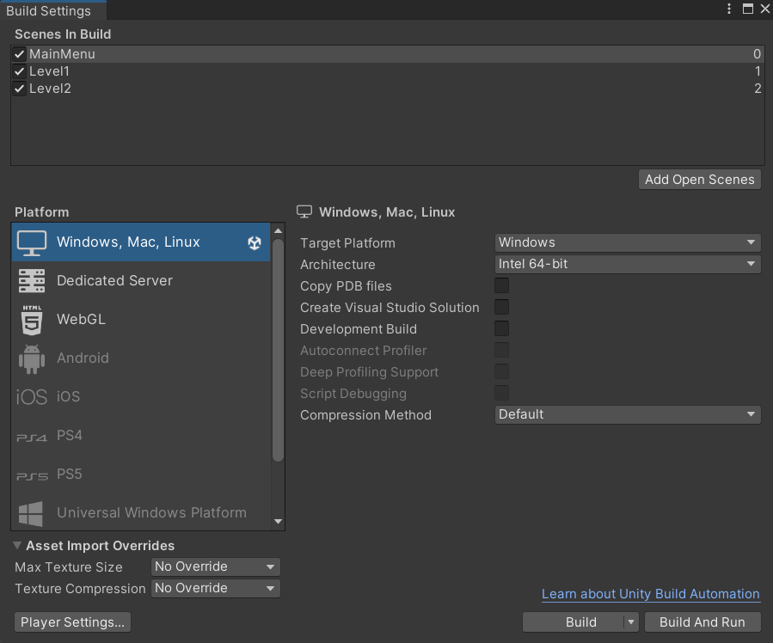

After adding scenes now just play the game.